We are happy that you are considering joining our GoMuseum team

You only have to fill out PART I of this form, save it and upload it to start a conversation
with us.
If you are ready to fill out more, please have a go at PART II.
In any case we will contact you as soon as possible for a talk about how to move forward

PART I

Your
contact info
Name:
Email:
Phone:

NB! We will not give or sell your information to any third parties
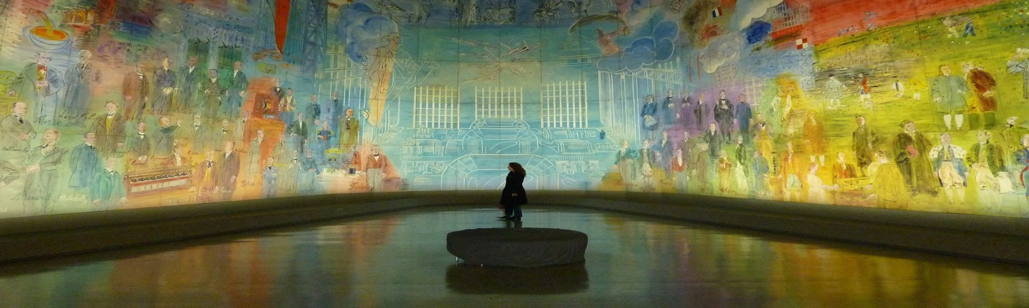

A bit about you. Give us something to talk about:

PART II

Your guide profile text, max 250 characters including spaces:

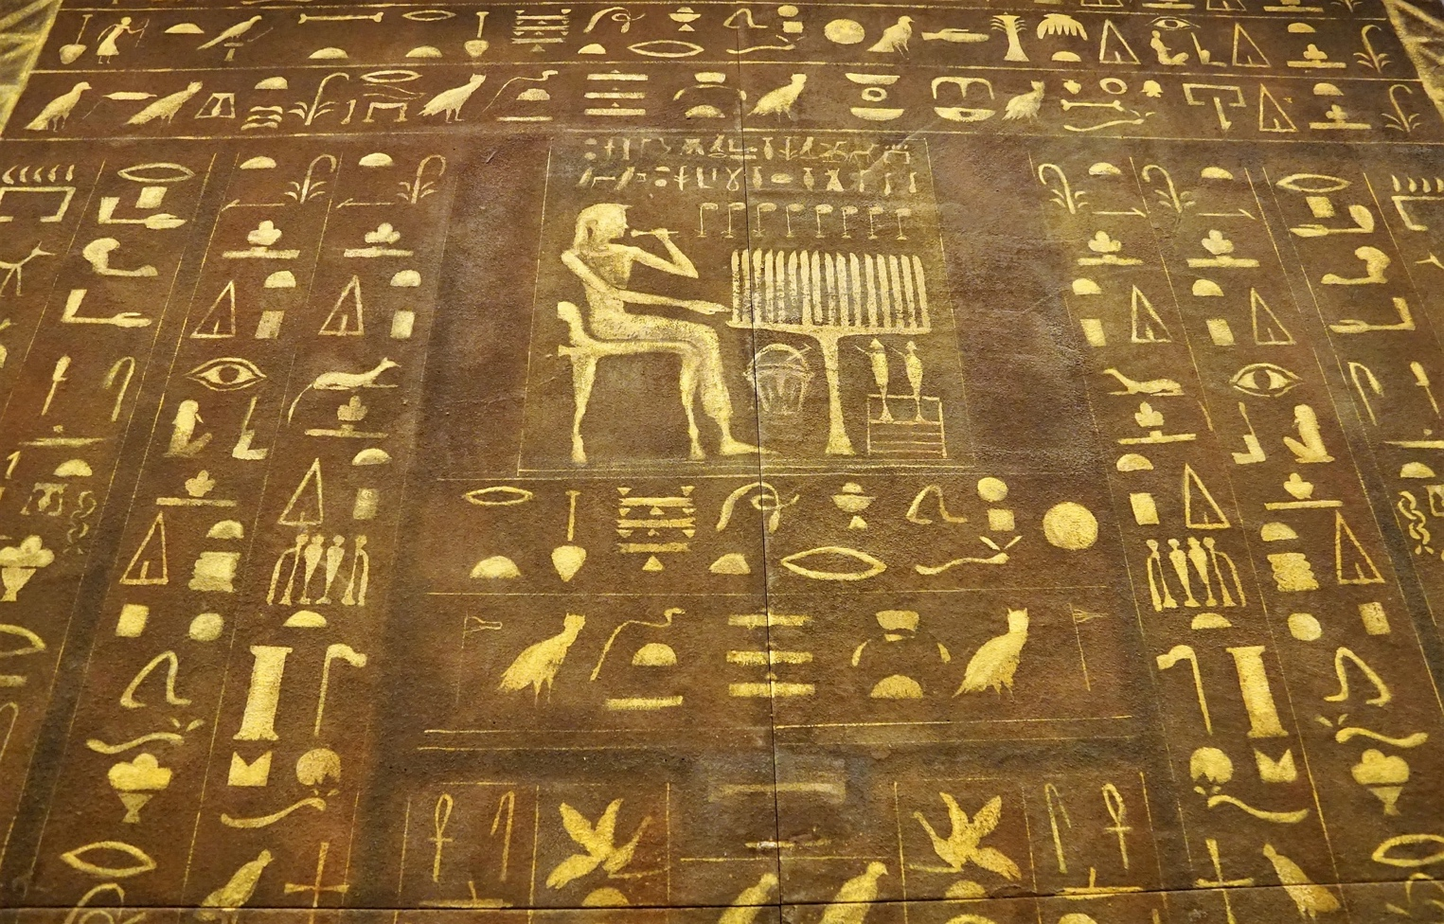

1, 2 or several tours:

Highlight tours
Tour title and museum city/name | Tour description, including which sections and  topics are covered. Duration of tour.
Highlight tours are broad and include the most revered or famous items in a museum

Children’s tours
Tour title and museum city/name | Tour description, including target age. Duration of tour.
Children’s tours are specific themed experiences aimed at children and/or parents

Signature tours (your very own creations) – we love a catchy headline!
Tour title and museum city/name | Tour description, theme – interest – emotions– covered sections/topics. Duration of tour.
Your signature tours are your favorite tours – they can be poetic, bring certain themes forward or invoke other creative storytelling techniques

Max 100 characters per tour including spaces. You may suggest photos.

Maximum group size
Choose maximum group size. Match the group size individually to the tours you are offering
Your tour rate in EUR* (GoMuseum will add a fee to your rate)
The tour rate shown in the GoMuseum app is your rate PLUS the GoMuseum fee. Tipping cannot be expected.

